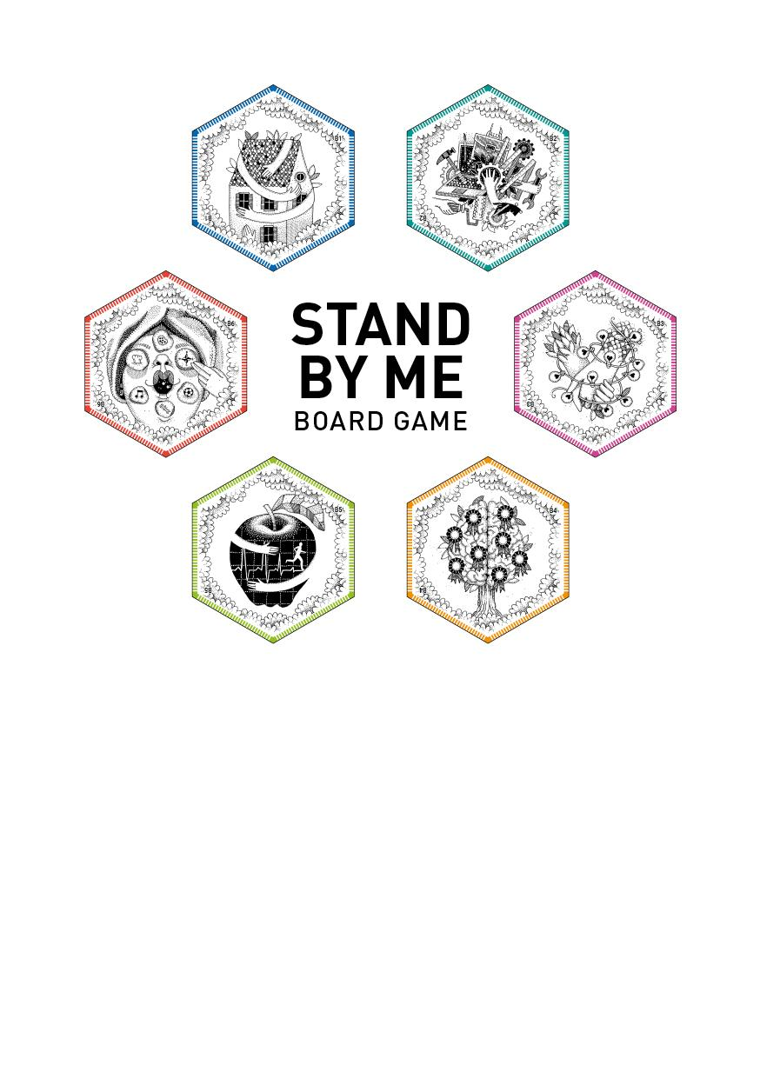

GUIDELINES



Stand by Me is an open source board game   
under a Creative Commons License   
(Attribution-ShareAlike 3.0 Unported – [CC BY-SA 3.0](https://creativecommons.org/licenses/by-sa/3.0/)).

The **Stand by Me Board Game** is downloadable   
for free on <http://bit.ly/standbymegame>.

It’s editable and might be modified by users   
in order to adapt contents to specific needs   
(language, gender-balance, type of story).

Enjoy!

#### 

#### INDEX

|  |  |
| --- | --- |
| Short Introduction | pg. 4 |
| The Stand By Me Board Game  Outlines | pg. 5 |
| Overview On The Stand by Me  Board Game Components | pg. 7 |
| How To Play – Step By Step Guidefor Game Masters | pg. 16 |
| Debriefing | pg. 23 |
| About  Stand by Me | pg. 25 |
|  |  |

# 

## 

# Short introduction

The SBM Game is thought to help people to think about **autonomy**. It is designed for people who are experiencing a process of transition – young people and adults leaving the care system and in need to acquire independence – and for the social workers and professionals that support them. So, the players could be: youngsters and adults who are going to leave care, care-leavers ageing out of 18, professionals committed in the educational and care system and more in general youngsters approaching adulthood.

The game is set in a parallel universe where 16 years old boys and girls are compelled to leave their own families and explore the world, facing the challenges of life: to cultivate personal relationships with other people, to stay healthy, to study and train, to find a job and a house, to cultivate their own interests, to manage their own resources.

Depending on the type of players involved, the SBM Game can be used as:

* an ice-breaking tool at the beginning of a deeper discussion on autonomy
* an educational tool (if played with care-leavers, youngsters and adults in transition)
* a training tool (if played with professionals) on how to approach the discussion on autonomy with youngsters

Therefore, the game is divided into 2 different sessions:

* A playing session
* A debriefing session

These two sessions can last and be managed differently, depending on participants, on the context and on the specific educational and training needs.

The person who leads the game is the Game Master.

The SBM Game was designed drawing on the results of a consultation process that involved young care-leavers, former care-leavers and several professionals involved in the care system in 4 different countries, within the European funded project *Stand by Me – Social-Ecological approaches for care-leavers inclusion through participatory policymaking*. Characters, challenges and emotions mentioned, stories and events experienced in the Game are inspired by care-leavers’ stories, ideas and suggestions.

##### **Disclaimer**: This game is based on fiction and any reference to people, places, and events are purely coincidental. All contents and characters of the SBM Game have been created in respect of cultural differences, gender balance and language differences.

# The Stand By Me Board Game Outlines

#### Duration:

playing session >1h   
+ debriefing session >1h

#### Target group:

youngsters and adults who are going to leave care, care-leavers ageing out of 18, professionals committed in the educational and care system and more in general youngsters approaching adulthood.

#### Group size:

from 2 to 6 players per group + a Game Master who act as the facilitator and storyteller of the group. Number of groups: from 1 to multiple (more than one group might play at the same time).

#### Location:

a place with table and chairs or even on the floor – indoor or outdoor.

#### Materials needed:

a table with as many chairs as players,

a pen for each player,   
at least 1 die.

6 tokens to identify each player:

Small cork stoppers

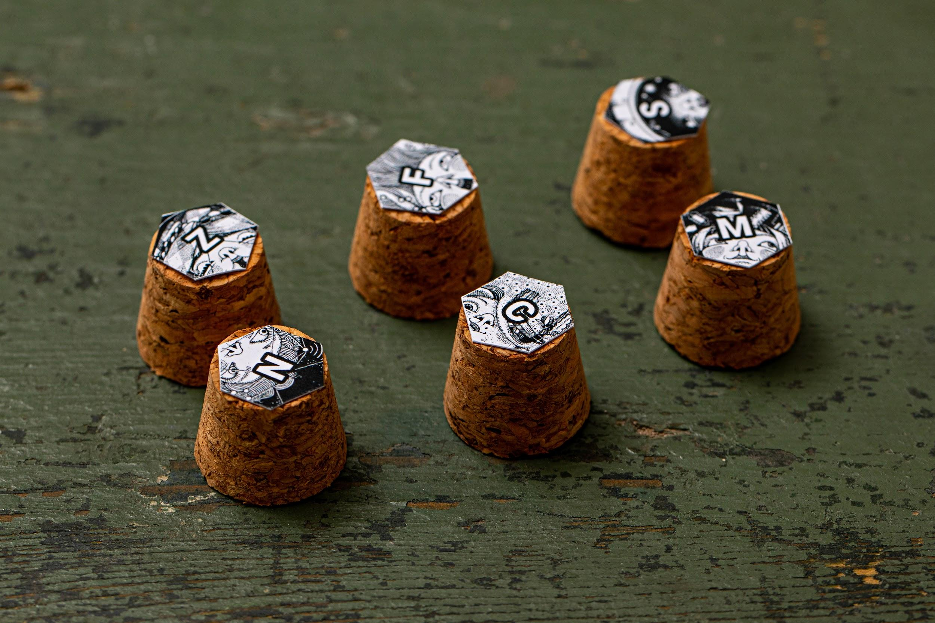

Or cubes

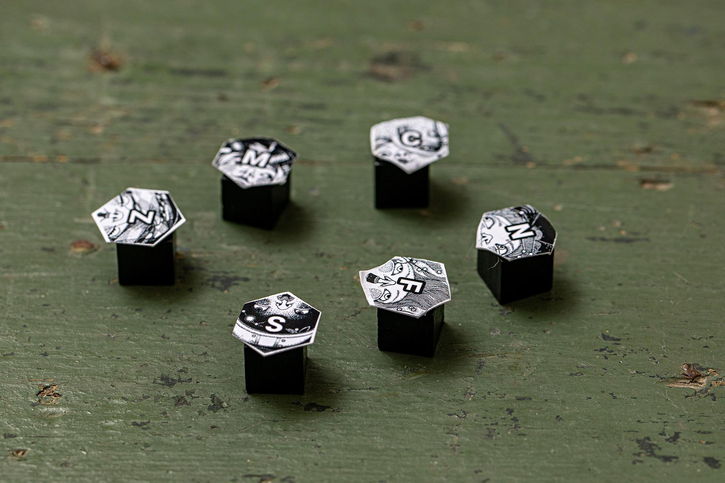

4 tokens for each player to track resources: Cubes (diameter max 1 cm) - you can find them easily on ecommerce website



or either



#### 

#### The SBM Board Game KIT includes:

* 39 hexagonal cards (6 PLAYER cards, 6 CHALLENGE cards, 24 GAME cards and 3 JOKERS)
* 6 Player Charts
* The booklet of Cards&Stories
* The Guidelines of the Game

#### Desired learning outcomes:

To approach and discuss adulthood as a path towards autonomy.

To raise awareness on the challenges and opportunities of becoming autonomous

To promote the development of life skills related autonomy.

#### The Stand by Me Board Game is:

Downloadable ⇒ on <http://bit.ly/standbymegame>

Free ⇒ no fee required

Printable ⇒ accessible and common formats (A4, A3)

Editable ⇒ the booklet of Cards&Stories (.doc) is editable and might be modified by users in order to adapt contents to specific needs (language, gender-balance, type of story).

Low cost ⇒ designed also in b/w version, some components are easy to get from ordinary objects.

#### **Created by:**

project Stand by Me REC–RCH–PROF–AG–2017–785708

In collaboration with: wemake.cc (featuring smarketing°)

Illustrations: strambetty.com

#### **For more info on:**

standbyme.rec@gmail.com

# 

# Overview On The Stand by Me Board Game Components

## The Board Game

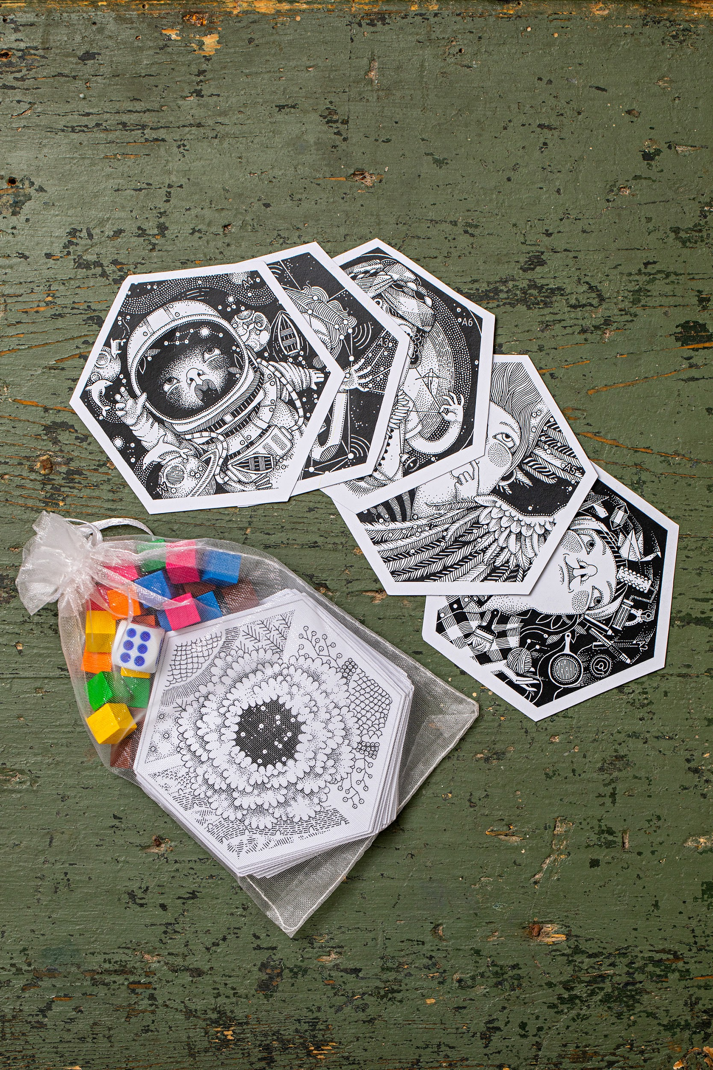

## The Cards

There are totally 39 hexagonal cards:

* **6 PLAYER** cards identify each player with a character
* **6 CHALLENGE** cards appoint each player with a main mission
* **24 GAME** cards and **3 JOKERS** are played in the game.

Each GAME card introduces one or more experiences/stories related to the 6 main CHALLENGES faced in a path to autonomy.

The story or experience related to the card will be narrated by the Game Master to players.

Each GAME Card displays a colour and a symbol, to easily identify the corresponding CHALLENGE.

#### 

#### In details:

### 

### A. PLAYER cards

#### On the front, every PLAYER card has a different character that matches a corresponding Player Chart. Each character has a special feature and a superpower, which are described on its Player Chart.

#### 

#### back

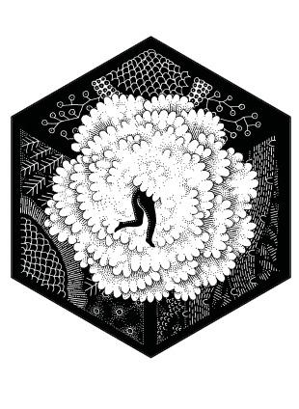

#### 

#### front

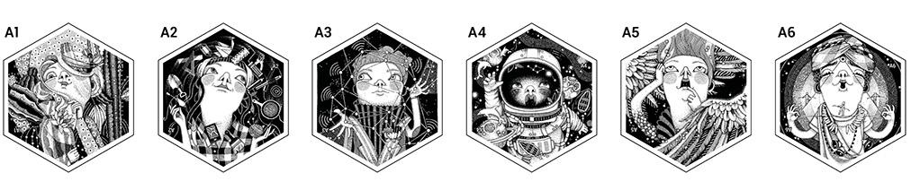



### B.PRIORITY CHALLENGE cards

These cards define the main CHALLENGE that each character will face during the game; they are turned face up at the beginning of the game by each player.

#### back

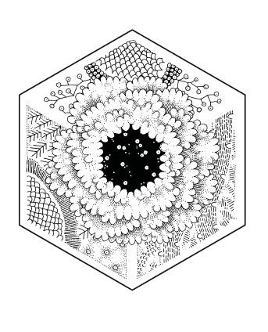

#### front

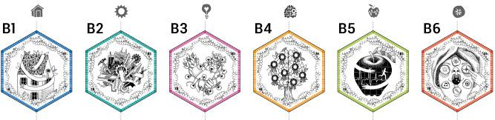

**HOUSING**  
To get a roof over your head but, primarily, to have a place where a person can feel good and safe is a priority for everyone. Finding a place is a tough challenge, especially for young people!



**WORK**To get a job is essential to cope not just with our basic needs! Nowadays, to get a job is not easy, a job where our rights are respected, a job that gives us certainty for the future.



**RELETIONSHIPS**Friendship, love, family relationships... these are bonds that can make us feel good but can also make us suffer. The aim is to take care of the positive relationships and to loose the complicated ones.



**EDUCATION**To broaden our cultural horizon, knowing, learning and training allow us to have more chances and to get what we aim in life.



**HEALTH**Health first! To feel good physically and psychologically is important for everyone, even if sometimes we forget about it, involved as we are in daily life events and challenges.



**WELLNESS**To take care of ourselves, do what we like, to reach an internal equilibrium... easy to say, hard to do! Well-being is the starting point to deal with everyday activities and cope with life challenges.

### C. SECONDARY CHARACTER cards

#### These cards refer to stories and experiences in which the player meets different characters and interacts with them in different ways (= see related experience on the booklet of Cards&Stories).

#### 

#### front

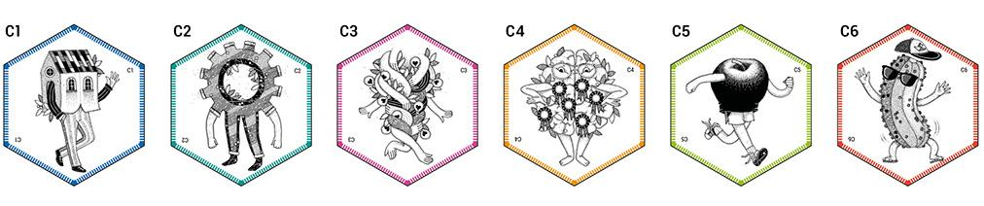



#### back

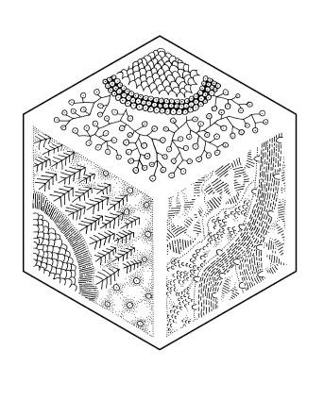

### D. SURPRISE cards

These cards refer to unexpected events related to the 6 CHALLENGES that occur to the player when lands on them (= see related experience on the booklet of Cards&Stories).

#### front

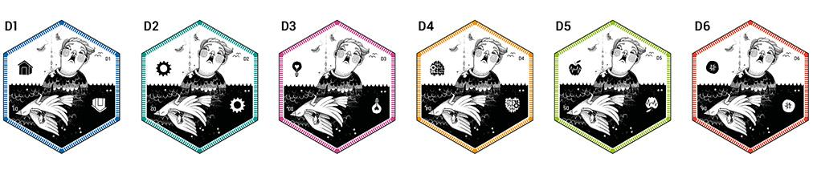



#### 

#### back



### 

### 

### 

### E. TASK cards

These cards refer to stories and experiences in which the player has to carry out different tasks related to the 6 CHALLENGES (= see related experience on the booklet of Cards&Stories).

#### front

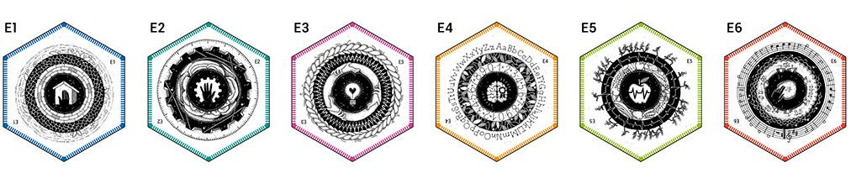



#### back



#### 

### 

### 

### F. EMOTION cards

EMOTION cards, unlike the previous ones, are not related to a single CHALLENGE. Emotions are intended as a common link between challenges. Therefore, the specific CHALLENGE of the card is described by the story or the experience revealed on the booklet of Cards&Stories, and depends on the score of the die.

The emotions are: Respect, Hope, Happiness, Anxiety, Anger, Loneliness.

#### front

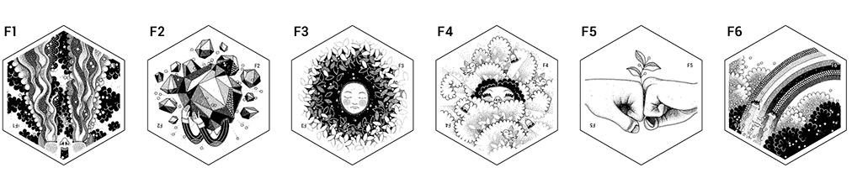



#### back



#### 

### G.JOKER cards

These cards will give the player a surprise (= see related experience on the booklet of Cards&Stories).

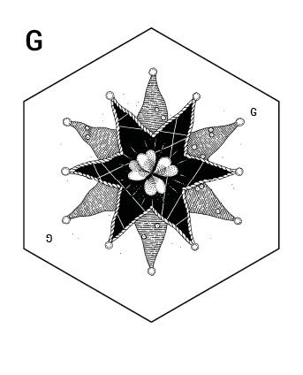

# 

# 

## The Player Chart

Each player is provided by a Player Chart, corresponding to the Character he/she selected. The Player Chart looks like this:

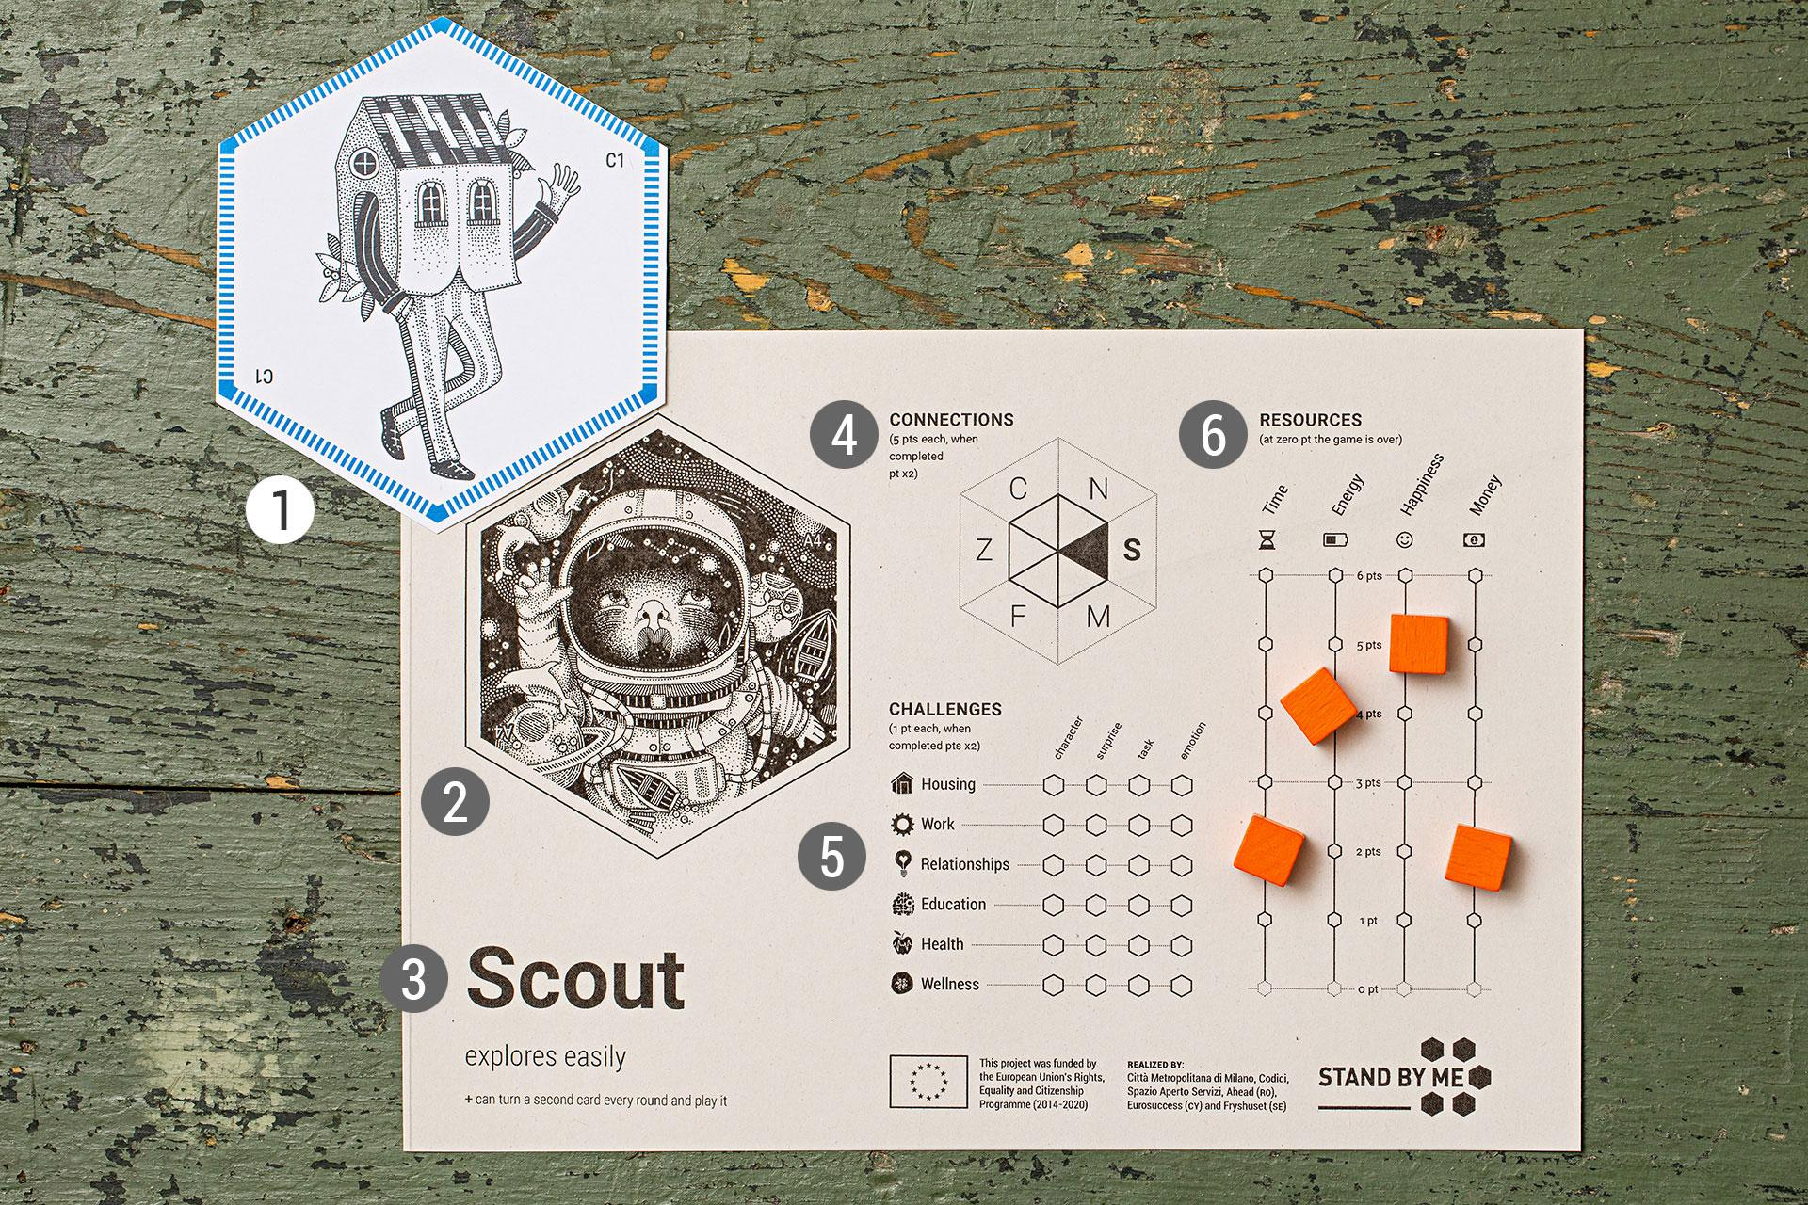

|  |  |  |
| --- | --- | --- |
| 1.PRIORITY  2. PLAYER  3.Name superpower | 4. CONNECTIONS Hexagon to track connections with the other players (by filling in the initialled triangles) 5. CHALLENGES graph to track  the fulfilment of the challenges experienced (filling the corresponding hexagon with a pencil). | 6. RESOURCES "thermometer" to monitor the levels of the resources (time, energy, happiness, money) gained and lost  in the game (using the resource-tracking tokens). |
|

## 

## The Cards&Stories booklet

Each combination of number of die rolled and type of card where the player lands on is associated to a brief event or experience.   
All experiences are related to the different challenges that the players are facing and each story ends with a consequence or action to be done. The booklet has 1 page per each type of card:

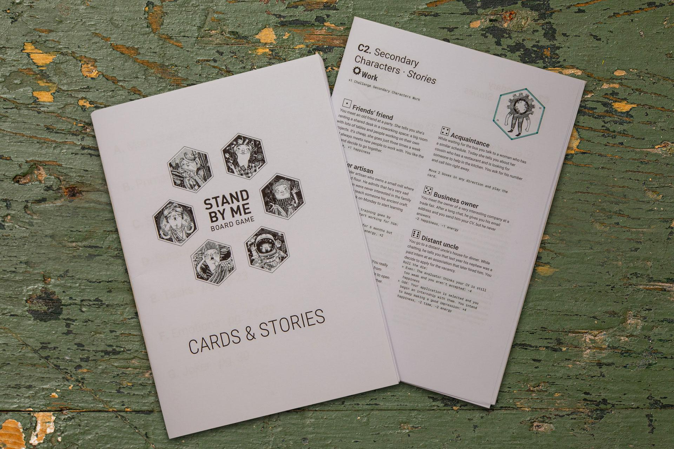

**Pg.4 – Main Character** contains the description of all 6 main characters.

**Pg.5 – Priority Challenge** contains the description of all 6 challenges that players are facing.

**Pg.6 – Secondary Character, D-Surprise, E-Task** and **F-Emotions** contain the stories associated.

Task of the Game Master is to read aloud the corresponding story to players.

**Example:** the player has landed on a SECONDARY CHARACTER card linked to the challenge Housing by rolling a 1 on the die. The story associated to be read is entitled ‘Friend and host’ (see image below).

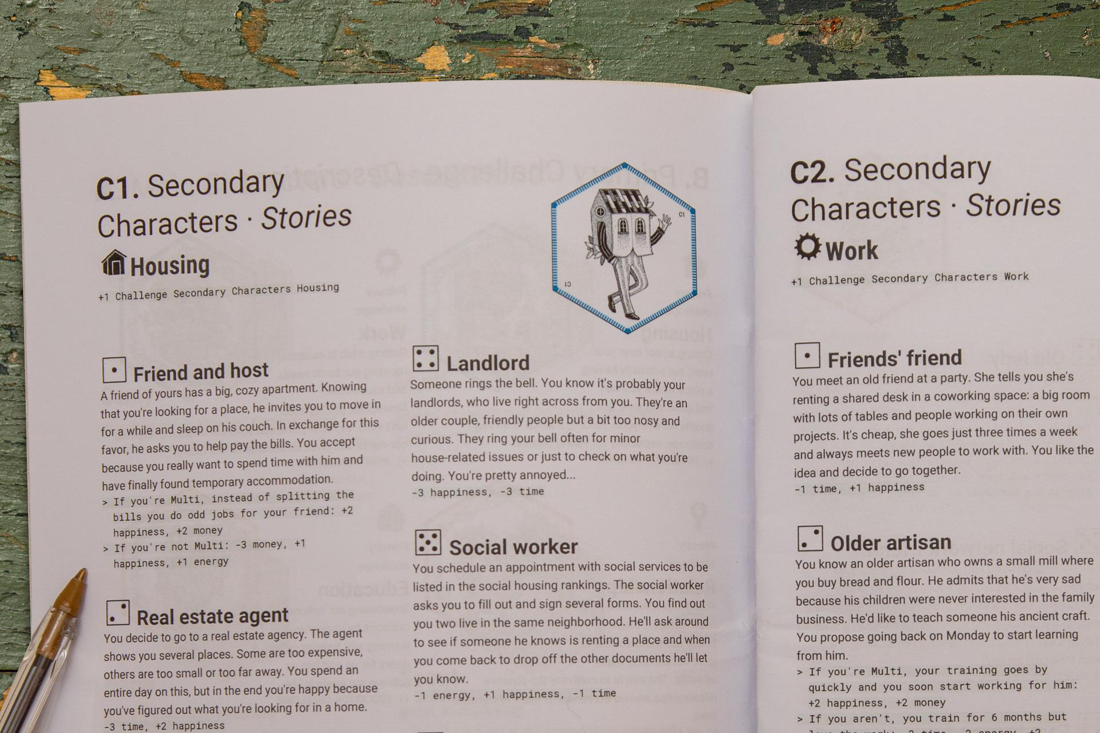

The booklet is a .doc file, downloadable and editable, so that stories might be **translated in other languages**, but also **changed completely or modified** according to training needs, target group of players or national cultural differences.

### 

### 

### Read me first – for Game Masters

The Game Master should carefully study the game rules before playing, in order to guide and help the participants. A well prepared Game Master is able to make the participants play even though they play for the first time or they do not know all the details of the game, but only the main dynamics. This allows the game to be accessible and fluid even if it is played in a single session.

 As a Game Master you will serve as the game's facilitator and storyteller.

Notably you will:

Introduce the game, explaining with the proper emphasis the context and the framework where the players are;

Describe the characters and their superpowers when they are assigned to the players;

Illustrate the different challenges of life when they are dealt to the players.

Read the stories and experiences from the Cards&Stories booklet every time a card is turned face up or is played;

Monitor the use of superpowers;

Remind the players every turn that it is possible to trade the resources between connected players.

So, let’s play and have fun!

# How to Play – step by step guide for Game Masters

## 

### Step 1 – Game set up (30’)

Download the SBM Board Game KIT.

**Print the KIT as follows:**

#### Cards:

on A3, preferably on white paper 200 gr

#### Player Charts:

on A4, 100 gr/200gr white paper

#### Players icons for tokens:

on A4, 100 gr/200gr white paper

Cut around forms, as shown:

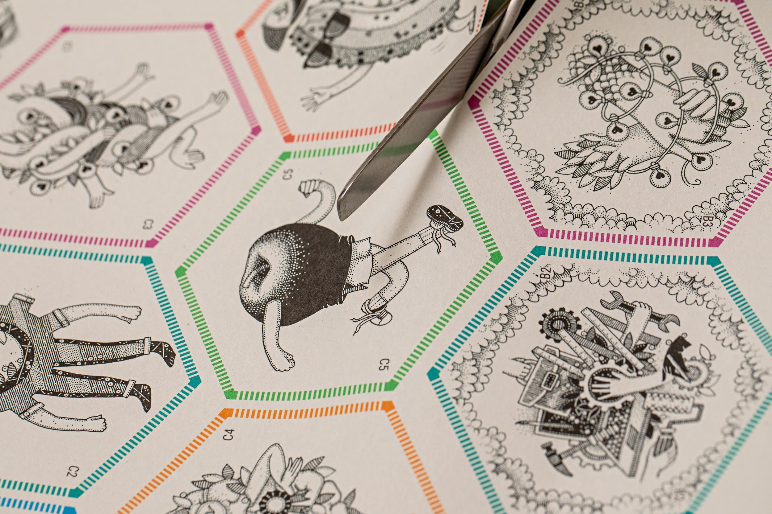

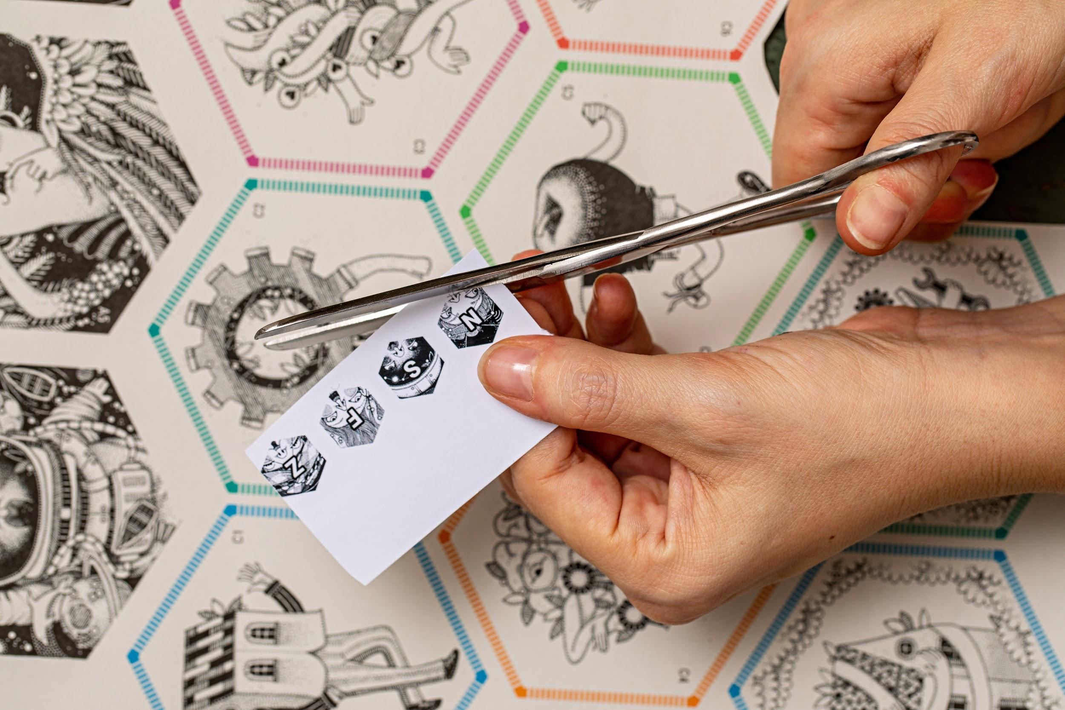

Shuffle the cards and randomly places them face down in the middle of the table, composing the Board Game using the 39 hexagons.

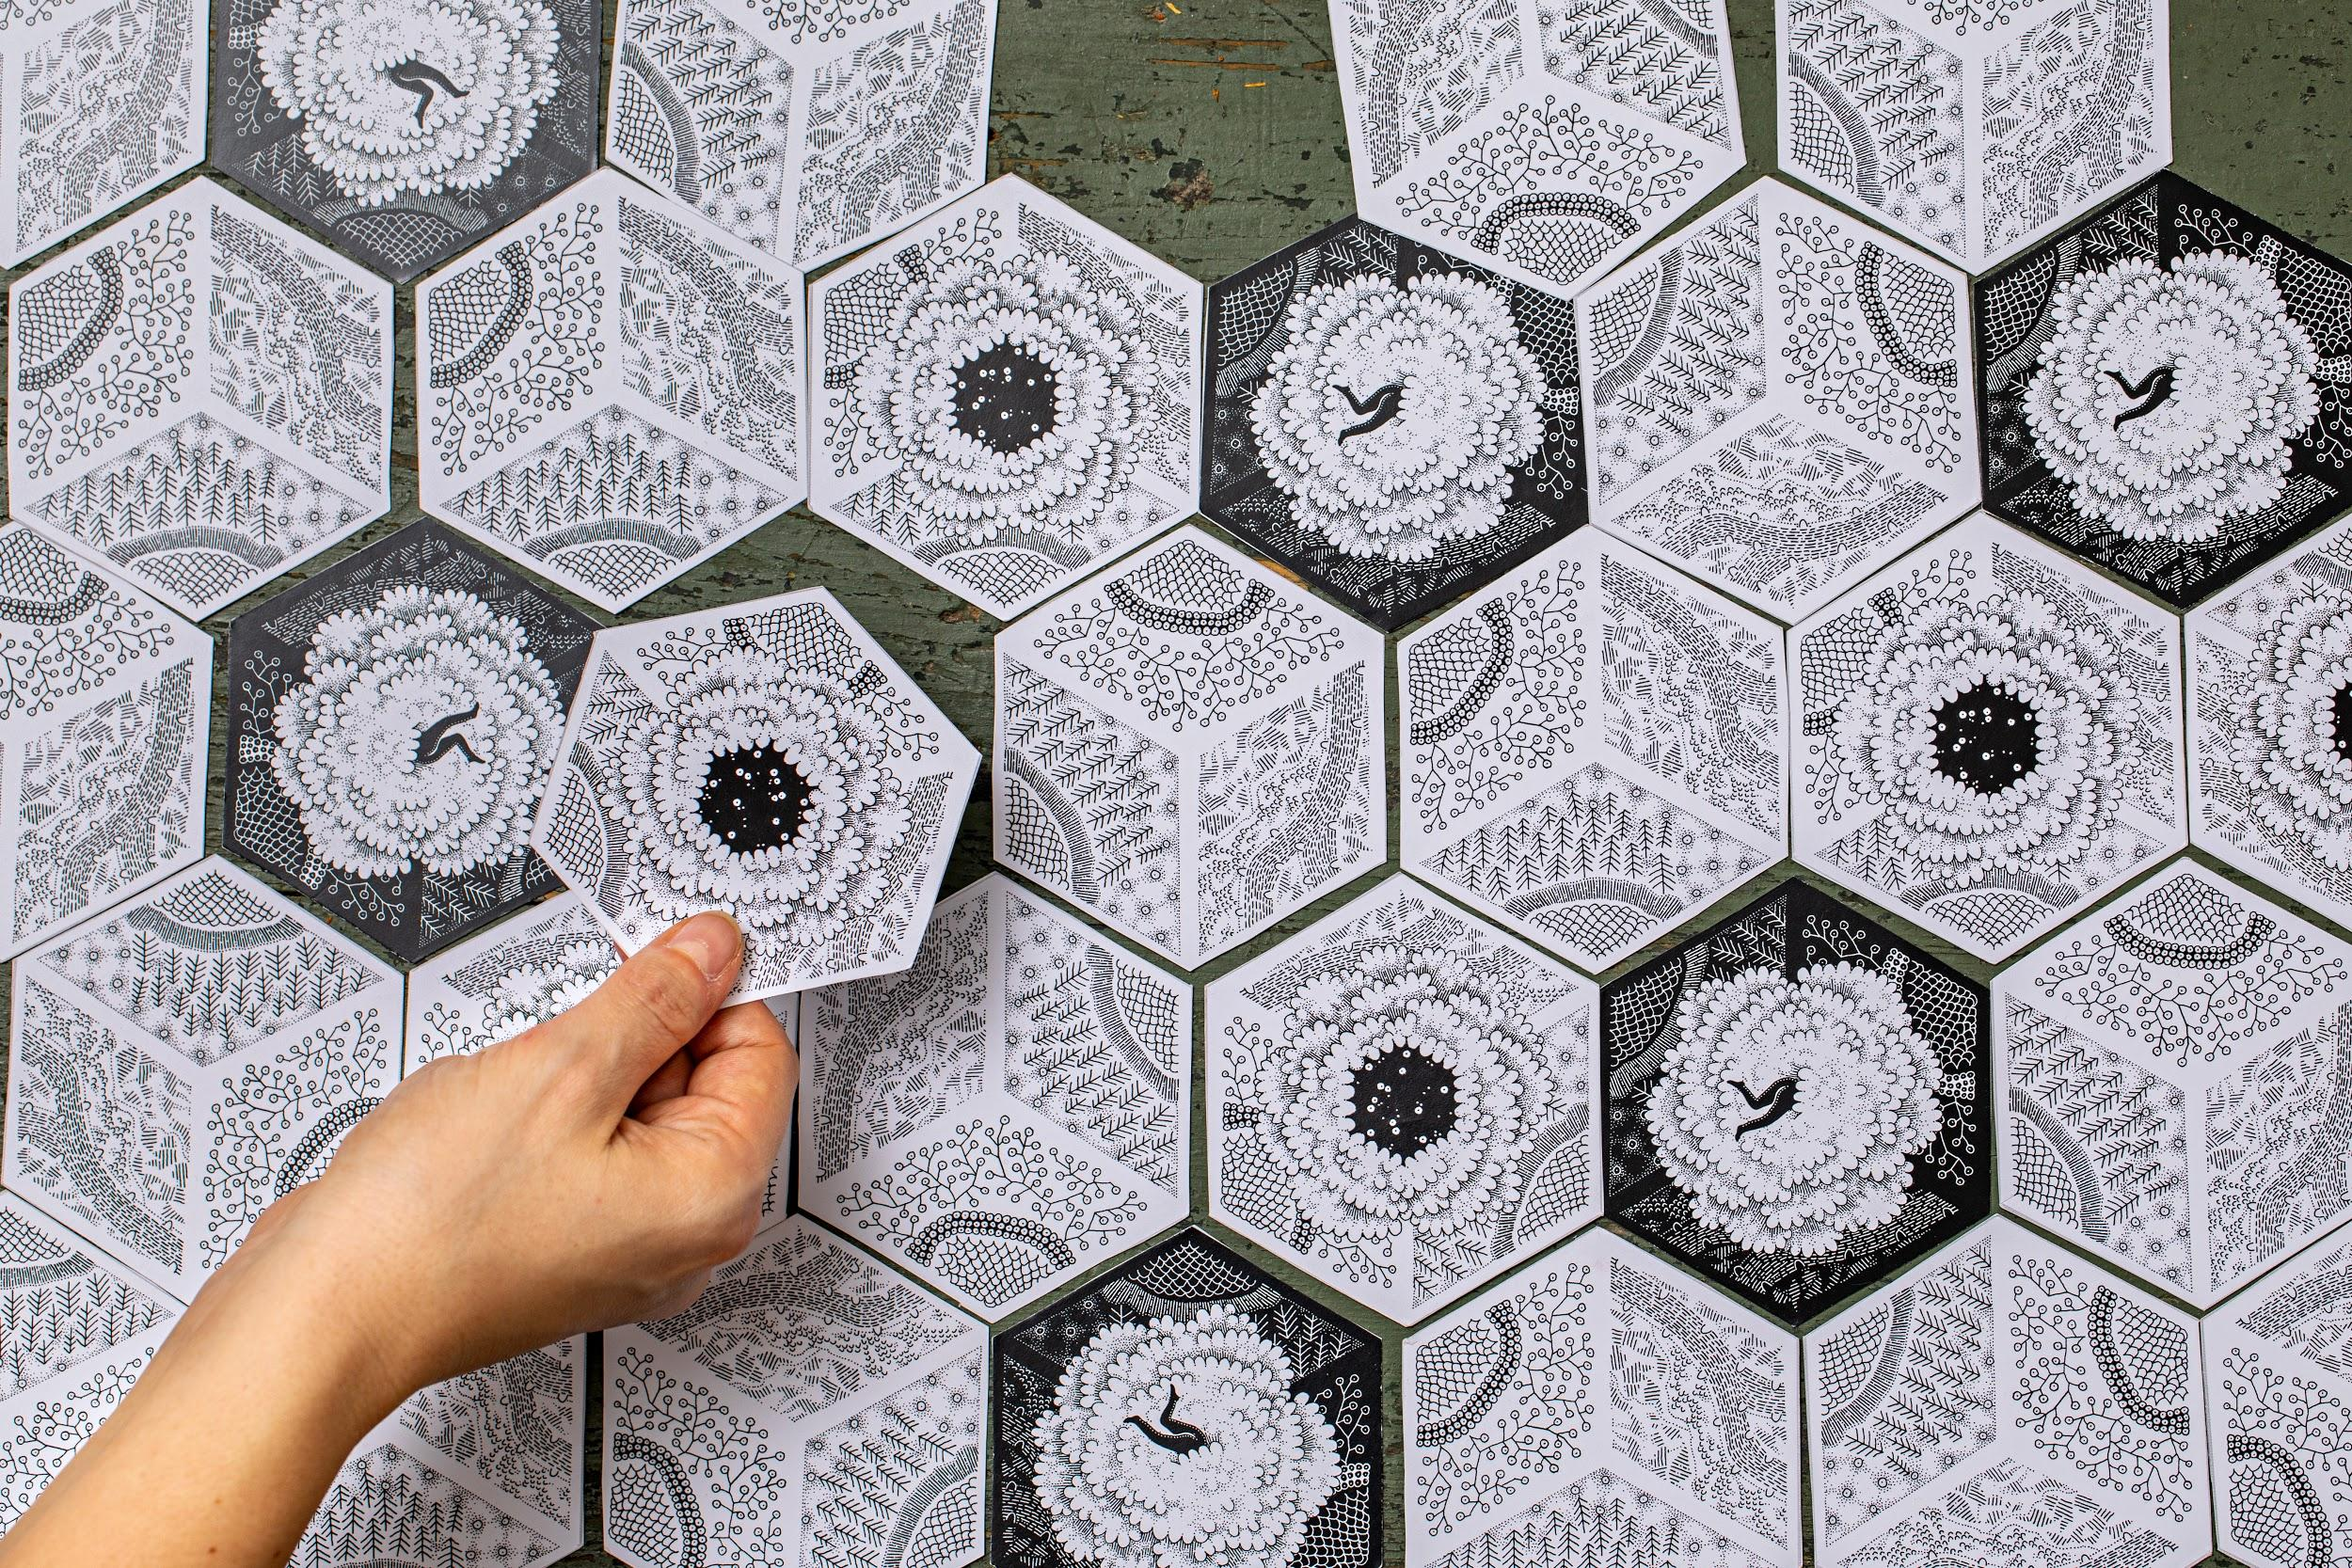

Place nearby:

* the 6 Player Charts
* the die (dice)
* the booklet of Cards&Stories

Make sure everyone is sitting around the table and pays attention.

### Step 2 – Introducing the game to players (15’)

**1.** Welcome everyone and thank them for participating and introduce yourself as the Game Master.

**2.** Tell players for how long the game and the following debriefing will last

Invite the players to choose a PLAYER Card: at the beginning of the game all 6 PLAYER cards are hidden face down.

You can recognize them from the back:

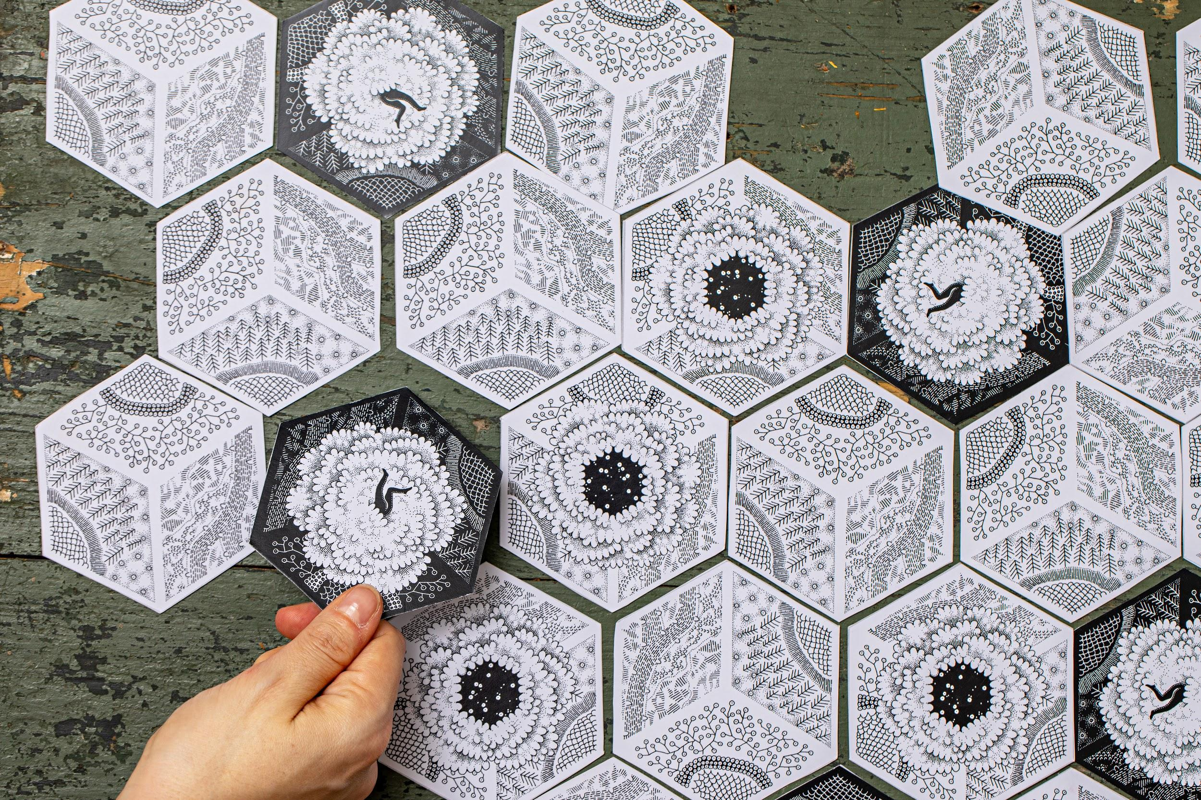

**3.** To set the turn order, each player rolls one die: the player with the lowest roll goes first, and is followed by the other players in clockwise order, until each player has chosen one PLAYER card.

The PLAYER Card he/she will choose will be the Character he/she impersonates during the game.

##### 

##### **!** If there are less than 6 players, some PLAYER cards will remain unassigned.

##### 

**4.** Give each player the Player Chart corresponding to his/her character. On the corresponding Player Chart, the character’s features are described (superpower).

**5.** Once the round is done and everyone has his/her own character, describe them to the participants or ask players to read aloud their character features. They have to get to know each other!

**6.** Make the players notice that in the Player Charts they can track their own resources levels (time, energy, happiness, money) by using the resource-tracking tokens, the collected experiences of the CHALLENGES and the connections established with other players.

**7.** Then, ask the players to place the 4 tokens on the Player Chart for tracking the starting point of their resources, according to colored circles, as shown:

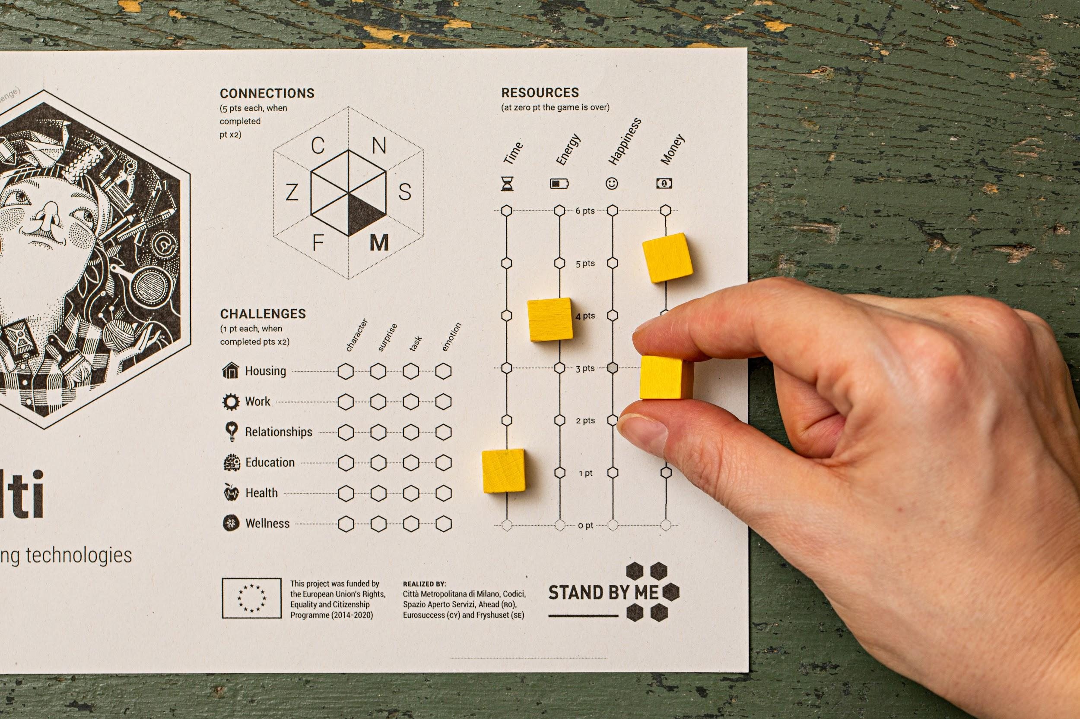

Beware that each player starts with different level of resources!

**8. Introduce the game scenario:**

The game is set in a parallel universe where boys and girls, after reached 16 years of age, have to leave their own families and explore the world, facing the challenges of life: to cultivate personal relationships with other people, to stay healthy, to study and train, to find a job and a house, to cultivate their own interests, to manage their own resources (time, energy, happiness, money).

You need to do all of this while balancing your resources and taking care of your own community, which is made up of all the participating players.

The community constitutes a single team, where everybody wins or loses together and has to work for a common score.

During the game, each player impersonates one of the 6 existing characters and moves on the Board Game by rolling the die and revealing the card where he/she lands. Each card describes an everyday life situation, which is read aloud by the Game Master.

**9. Explain the game goal:**

The object of the game is to maximise the group score of the community, and at the same time preserving the player’s resources, which should never fall below the critical threshold: the players must therefore keep their 4 resources levels (time, energy, happiness, money) above the level 0.

Every player has to complete one or more of the following **CHALLENGES**:

#### **HOUSING**

To get a roof over your head but, primarily, to have a place where a person can feel good and safe is a priority for everyone. Finding a place is a tough challenge, especially for young people!

#### **WORK**

To get a job is essential to cope not only with our basic needs! Nowadays, to get a job is not easy, a job where our rights are respected, a job that gives us certainty for the future.

#### RELATIONSHIPS

Friendship, love, family relationships... these are bonds that can make us feel good but can also make us suffer. The aim is to take care of the positive relationships and to loose the complicated ones.

#### EDUCATION

To broaden our cultural horizon, knowing, learning and training allow us to have more chances and to get what we aim in life.

#### HEALTH

Health first! To feel good physically and psychologically is important for everyone, even if sometimes we forget about it, involved as we are in daily life events and challenges.

#### WELLNESS

To take care of ourselves, do what we like, to reach an internal equilibrium... easy to say, hard to do! Well-being is the starting point to deal with everyday activities and cope with life challenges.

**10. Explain the game strategy:**

There are three different ways to score:

**A**. Collecting as many experiences as possible for every CHALLENGE, corresponding to 4 different kinds of cards the players will encounter on their path. For each CHALLENGE (Housing, Work, Relationship, Education, Health, Wellness):

* Some tasks have to be accomplished (TASK cards),
* Some adversities and opportunities have to be faced (SURPRISE cards),
* The players have to meet some secondary characters that may help them (SECONDARY CHARACTER cards)
* The players have to manage different kinds of emotions (EMOTION cards)

The achievement of each step can be tracked on a graph in the Player Charts, filling the hexagons located between the line of the corresponding CHALLENGE and the column of the GAME card where the player has landed.

**B.** Managing their own resources without exhausting them. Every experience faced by the players will impact on their resources, boosting or decreasing them.

There are 4 different kinds of resources:

#### TIME

#### ENERGY

#### HAPPINESS

#### MONEY

It is very important to pay attention to the resource levels!

When a player’s resource reaches level zero and it is not restored within his/her next turn, the entire game is over.

How can the players restore their resources? Through connections between characters.

**C.** Creating connection with other players. During the game, the participants can establish connections between other players. The connection is established when a player lands on a card already occupied by another player.

The connections with the players can be tracked on the hexagon on the Player Charts, filling with a pencil the triangle that matches the other character’s name.

The connections are fundamental to help the players to manage their resources: the connected players can, in their turn before rolling the die, exchange a resource, one unit at a time, according to their needs.

### Step 3 - STARTING THE GAME (20’)

* Let the players choose blindfold their own PRIORITY CHALLENGES: all 6 CHALLENGE cards are hidden face down, at the beginning of the game. You can recognize them from the back:

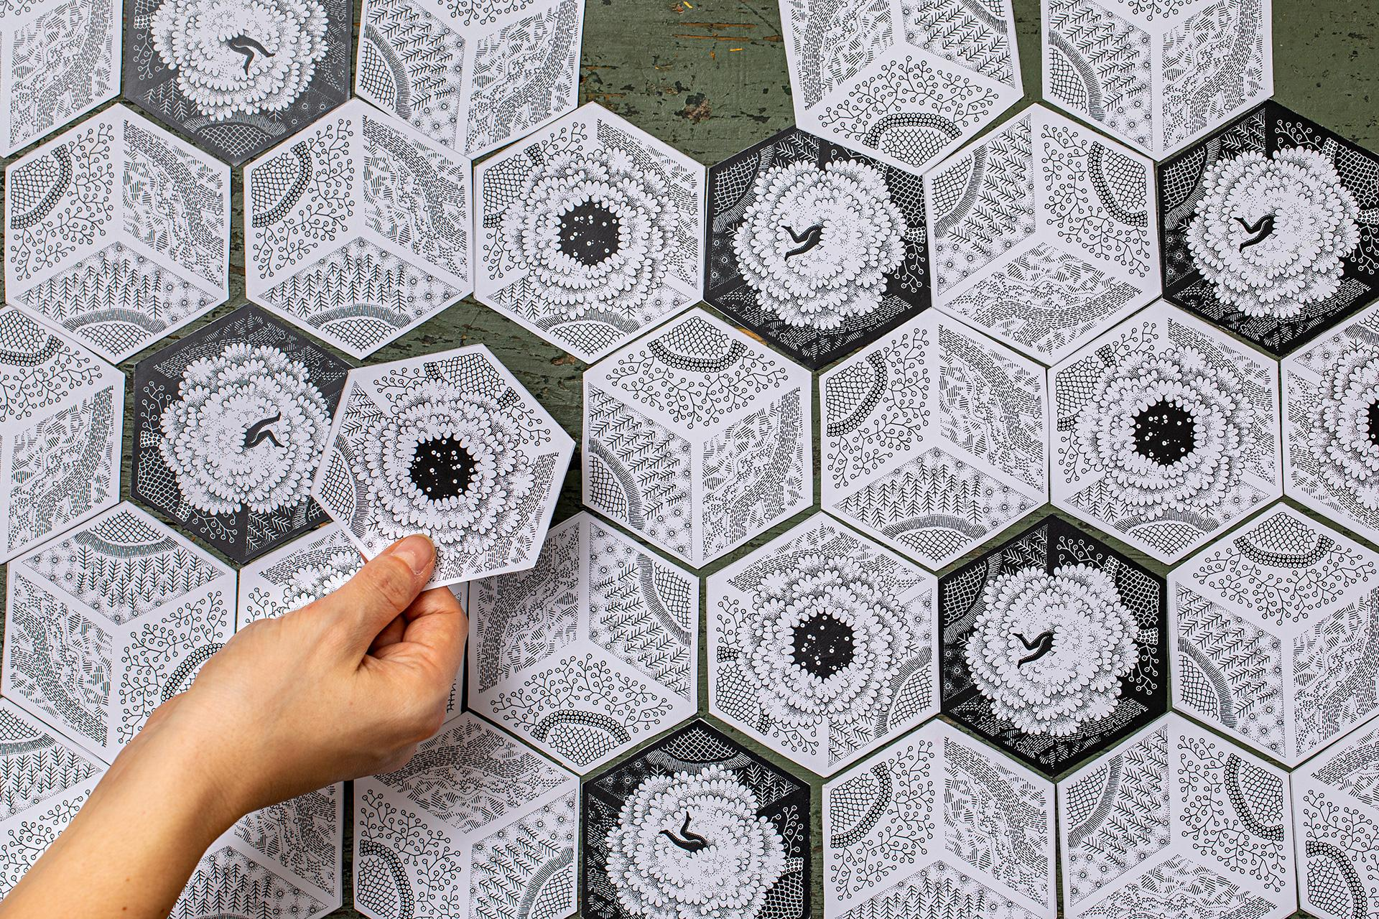

* Ask the first player to choose a PRIORITY CHALLENGE Card, reveal it and remove it from the Board Game, placing it in the corresponding area of his/her Player Chart, as shown:

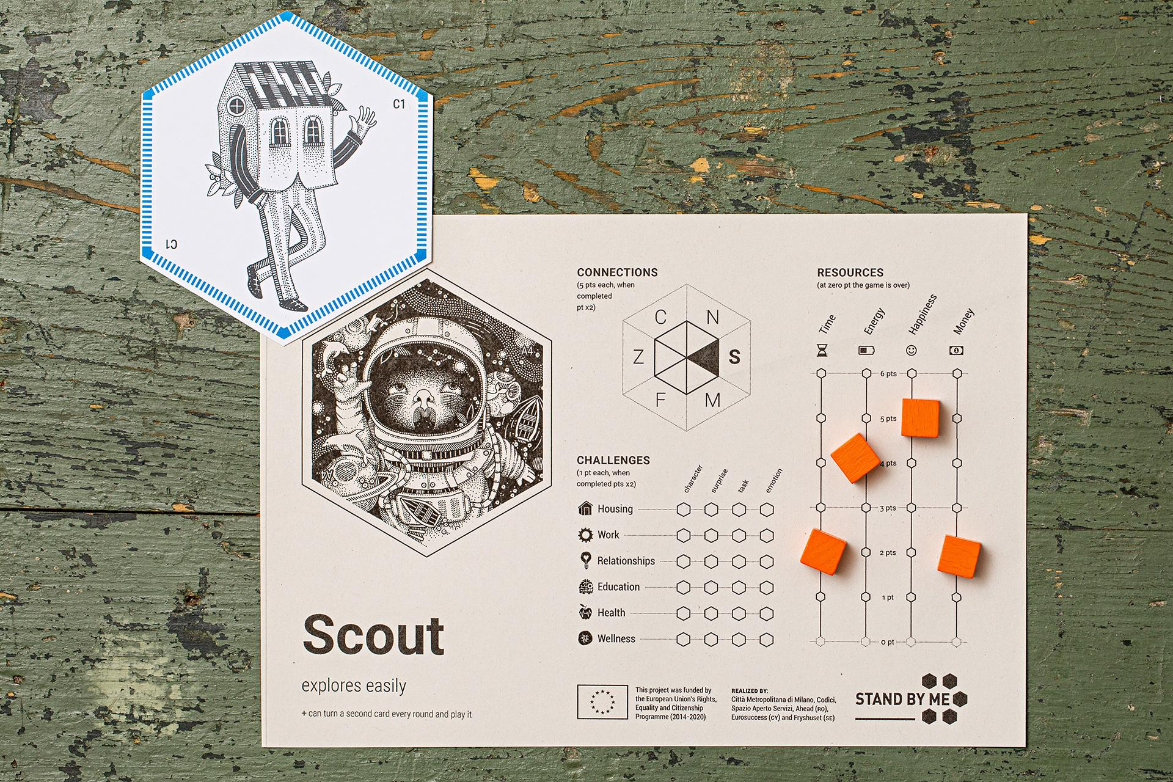

* Remind the players that the Priority Challenge is the main challenge of the player, the one where he/she can obtain the best results, his/her own specialty.
* Remind players also that the score obtained by the priority challenge shall be multiplied by 2 at the end of the game. In order to maximise their scores, the players should try to land on the cards related to their priority challenge, paying attention to the symbol and the colour displayed on them.
* The remaining players proceed then clockwise to discover their PRIORITY CHALLENGE Card; every time a new PRIORITY CHALLENGE Card is revealed, the Game Master will introduce the new topic.

##### 

##### ! If there are less than 6 players, some PRIORITY CHALLENGE Cards will remain unassigned; the Game Master will turn them facing up and describe them to the participants. These cards will be removed from the game and placed next to the Game Master; they represent some important themes still present in the game, even though they cannot multiply the players scores.

### Step 4 - TURN AND MOVEMENT (between 30’ and 45’)

Now the game goes on and gets to its core.

* Ask the next player to roll the die.
* Invite the player to move his/her token across the Board Game the amount shown on the die in their roll.   
  ! It is allowed to freely move in any directions, on cards that has already been revealed and backwards.
* When the player lands on a card that has not yet been revealed, invite him/her to turn it facing up.

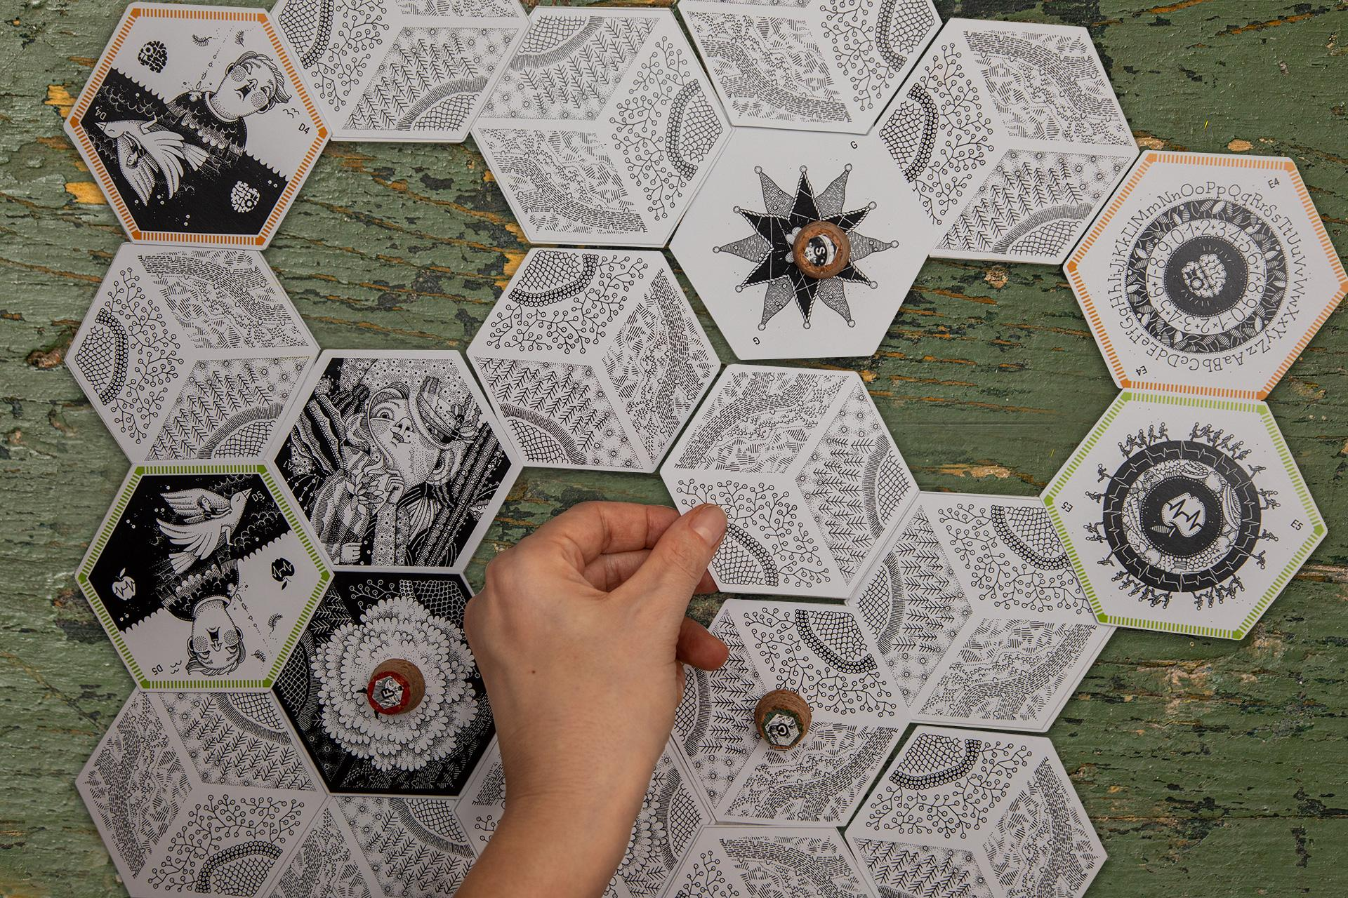

* Then take the booklet of Cards&Stories and read aloud the story/experience that matches the card, selected through the alphanumeric code on the card and the rolled score. Each story will provide player with an instruction on score or further action to do.

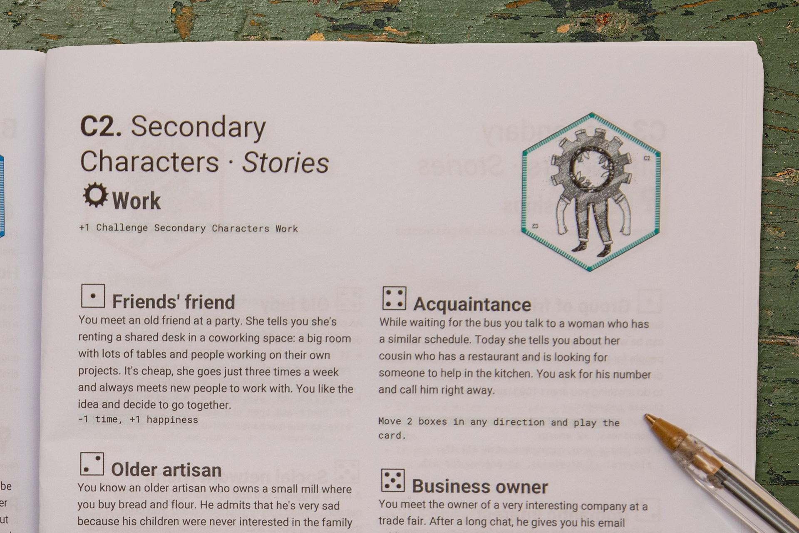

##### Example: I roll the die and get 4,then I move across the Board Game (4 movements) and land on card C2. The Game Master will read C2 (corresponding to WORK SECONDARY CHARACTERS page) and proceed to read the story with:

##### Acquaintance

##### While you are waiting for the bus you talk to a lady having a similar routine. Today she is telling you about her cousin that has a restaurant and that is looking for someone to help in the kitchen. You ask her his number and call him straight away.

##### Move 2 hexagons in any direction and play the card

* According to the end of the story, invite the player to follow instructions red and put in action (following the example, player will move 2 hexagons in any direction and play the card).

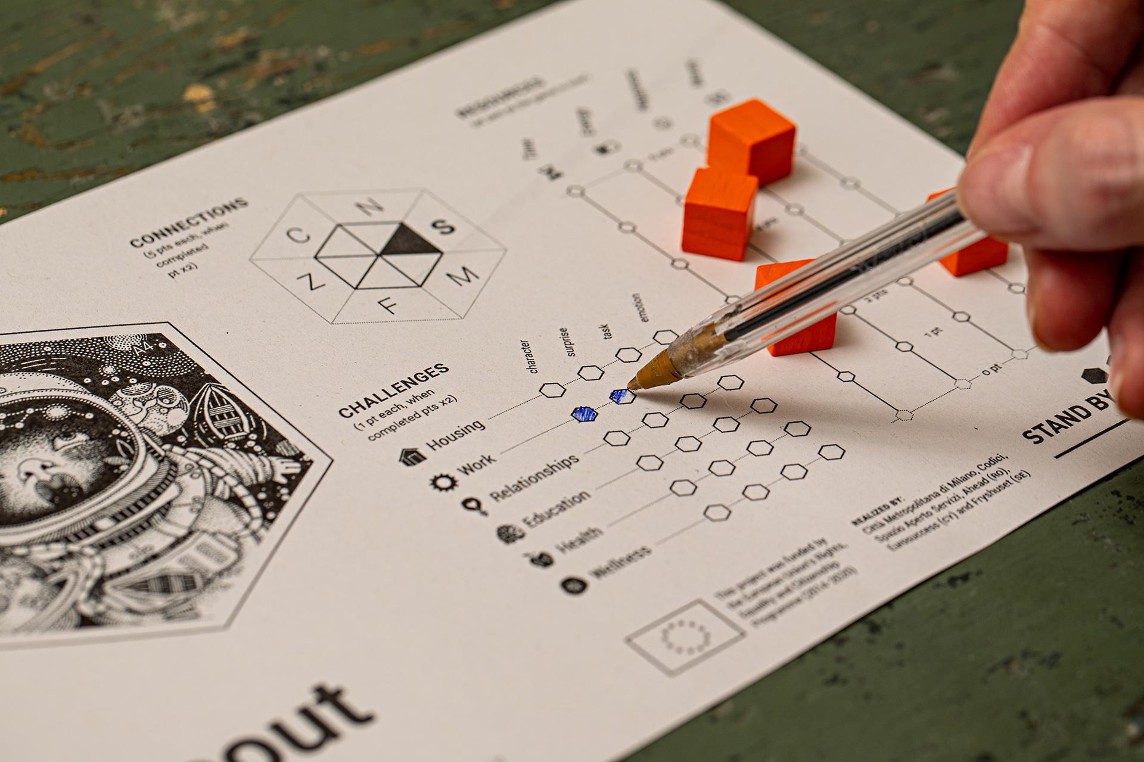

##### 

##### ! Whenever the player lands on a card, he/she has also to colour with a pen the box on the Player Chart corresponding to the combination between Challenge occurred and type of experience (Secondary Character, Surprise, Task, Emotion).

* Then it’s the turn of the next player.

If the players land on an already revealed card, the Game Master will read the story as shown in the above-mentioned example (since the stories depend on the number scored in the roll and every card illustrates 6 different stories, the risk of repetition is reduced).

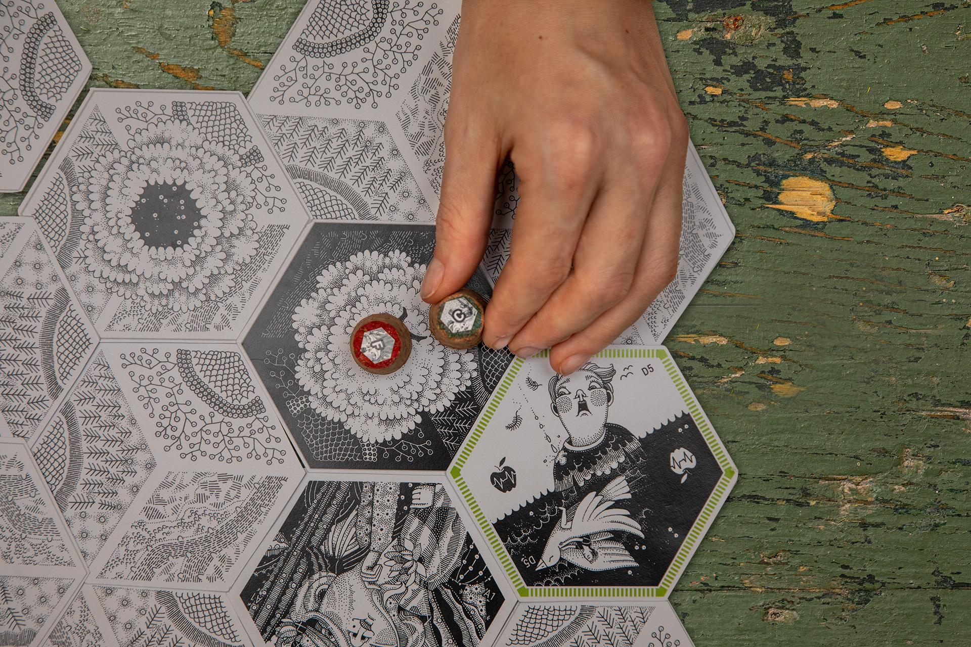

If the player lands on a card already occupied, a connection between the players on the same card is created (both of them fill the corresponding triangle with a pencil in the hexagon on their Player Charts).

The connected players can, from now, in their turn before rolling the die, exchange a resource, one unit at a time, according to their needs.

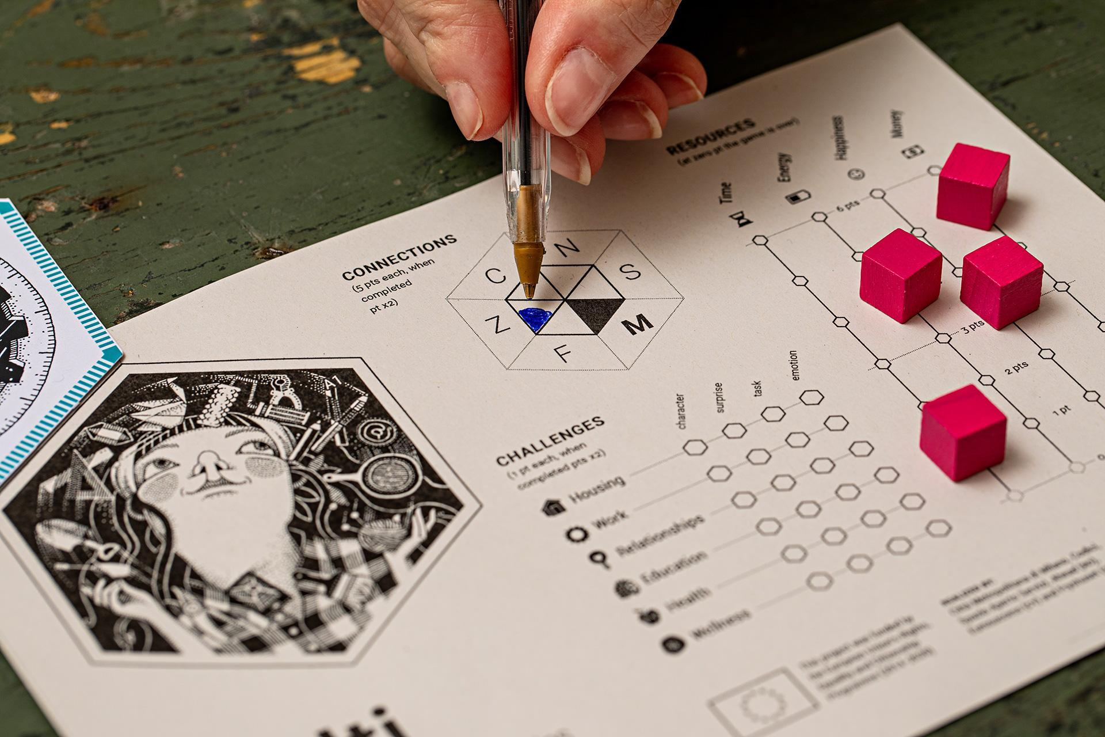

**If a player’s resource, despite the exchange system, reaches level zero**, the community has one round to help him/her restoring it. The player can be helped by using the exchange system, however, only two connected players can trade their own resources. If nobody is able to help the him/her, **the game is over for everyone**.

It is then necessary for the participants to pay attention to every player’s level of resources, not only their own one.

### Step 5 – SCORE CALCULATION

The game lasts for a specific amount of time established by the Game Master at the beginning of the game (60 minutes at least).

The game ends when:

* A player’s resource falls to zero and he/she is not saved by the other players or
* Time runs out

At the end of the game, each player calculates his/her own score; the individual scores are then added together to determine the group score.   
It is also possible to compete against other communities (group of players) which are playing concurrently, comparing the groups scores at the end of the game.

**So, once you’ve decided   
to stop the game:**

**1.** Ask each player to score the following points INDIVIDUALLY:

* For every CHALLENGES steps: +1 point; the score is multiplied for 2 if the CHALLENGE is the PRIORITY CHALLENGE (every story/experience/event score 2)
* For every completed CHALLENGE (the entire line is completed): +8 points; +16 if the CHALLENGE is the PRIORITY CHALLENGE
* For every resource level: the total score of resources is the sum of their levels tracked by the token at the end of the game
* For every connection established with other characters: +5 for each connection; the score is multiplied for 2 if the hexagon has been completed (50 points instead of 25)

The players can track the points they have earned on the Player Chart, filling the corresponding spaces with a pencil, as shown:

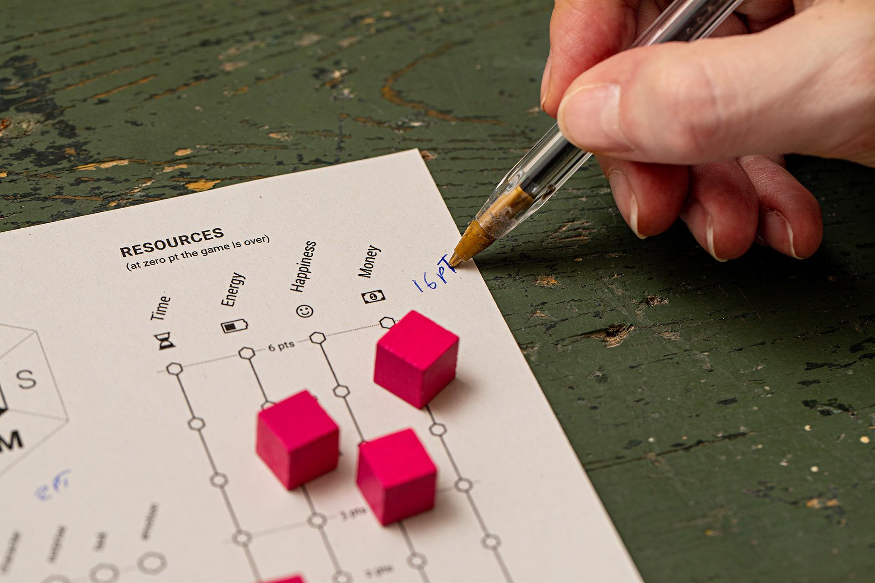

**2.** Now invite players to calculate the GROUP SCORE: sum up all player’s scores to obtain a group score. The score can be interpreted and communicated to the group as follows:

* score <...: "you still have to work hard to face the challenges of life, there is a long way to go!"
* <score>: "excellent score, but there are things to improve!"
* c. score> ... "you seem to be ready to face the challenges of life, good luck!"

##### ! If two or more groups are playing together, the two groups will be competing at the same time and you will see who makes the highest score.

# Debriefing

Debriefing is an element used in non-formal education and experiential learning which should take place after the game. Debriefing is a crucial part of the activity as it allows the participants to take a step back from the game and focus on **learning points** that can be extracted from the experience.

Ideally, the participants should be sitting in a circle and the Game Master leads the process, most commonly through asking questions.

### The Debriefing process has at least 3 steps:

1. **Reflection**: talking about feelings and facts – generally about what happened during the game;
2. **Conceptualization**: connecting the SBM Game experiences to real world situations;
3. **Application**: thinking about the future and how can the SBM Game experience change a person and his/her situation.

Pay attention to:

* It’s up to the Master to decide which step to stress, how much time to spend on each step and the type of questions used.
* The type of game participants is one of the main criteria to take into consideration in order to set up the debriefing process. So, the Game Master should choose the questions according to the audience.
* Writing down answers and feedbacks on a board or a large sheet of paper might help to better handle the debriefing process.

 Here there are some suggestions on questions that might be asked to start the process of debriefing.

Keep in mind that these questions are very vague and they can be modified to better address the specific learning outcome that is planned for the participants.

### With all kind of participants:

#### Starting the reflection process

* Which character did you like the most? Why? Do you know anyone who has the same features?
* As [name of the character] how did you feel?
* As [name of the character] how did you behave?
* How did the other players behave, according to their own actions?
* Choose the card you like the most and explain why.

#### Pointing out thoughts and concepts

* Which of the stories/experience/characters   
  did you find the most relatable?
* Have you ever experienced similar situations?
* Can you relate stories/experience/characters to your previous experiences? Which ones?
* Which of the challenges experienced do you find the most important, considering the path towards autonomy? Why?
* Which story/experience sounded less relevant to you, to reach autonomy? Why?

#### Apply to ordinary life

* How will I react the next time something similar happens? What would I do differently next time?
* How can this be applied in other situations/in daily life/in professional life?
* According to my situation, which steps should I start to make to achieve the different challenges of life in the path towards autonomy?

### 

### 

### If the players are professionals, youth workers or educators, some additional questions might be:

* Thinking about your professional activity, which theme/situation among the ones raised during the game do you believe is the most significant?
* Considering the main challenges (home, work, relationships, health and well-being), which are the existing tools to face them and which ones do you feel are lacking and urgent?
* Relationships, caring for others, attention to resources in a community sense..., how do these themes come across your professional experience?
* What connections do you see between your personal growth story, your job role and the issues covered by the game?

# About Stand by Me

## The project idea

Stand by Me is a transnational project, co-funded by the European Union, implemented in 4 European countries: Italy, Romania, Cyprus and Sweden. The project intends to shape and enable pathways for boys and girls, involved in different types of judicial proceedings, and leave the protection and reception systems (care-leavers). Through the participatory design of tools and working methods,

the project intends to improve the effectiveness and efficiency of the procedures to accompany young people towards autonomy, involving them in the process of designing and implementing the mechanisms to be adopted.

### What will it achieve?

* Consultation groups in each country, composed of young care-leavers, professionals and policy makers who will meet their peers to identify difficulties and critical junctions regarding rights and autonomy;
* Training tools and guidelines, built on the basis of the material emerging from the consultation process, which will guide the capacity building paths;
* Training of professionals aimed at recognize and address the needs and the demands connected to the path of young people ageing out of alternative care towards autonomy;
* Four online and offline awareness campaigns built on the basis of the consultation process;
* Capacity building for policymakers dedicated to the joint co-construction of an Operational Protocol that will outline common lines of work to improve the system of accompaniment of boys and girls towards autonomy;
* A final public event in Milan for 400 professionals, stakeholders and policymakers in the sector of the countries involved, aimed at sharing and formalizing a Transnational City Alliance, starting from the Operational Protocol.

## 

## The organisations involved



**Metropolitan City of Milan**

***Italy (coordinator)***

Formed by 134 municipalities for a total of 3.176,180 inhabitants, in the area of economic and social development Città Metropolitana plays a fundamental role in the promotion of equal opportunities, in contrast to any form of discrimination and therefore in the promotion of positive inclusion actions, placing at the center the rights of persons, especially of the young generations. With a long term experience in the area of continuing education and research, thanks to its international networks, the collaboration with the Court of Appeal of Milan and the Juvenile Courts, with the corporate of professionals and the most representative forensic associations, and nevertheless with the NGOs and the local authorities, Città Metropolitana develops a constant project activity, as core tasks of its Strategic Plan, both on community and national funds, as strategic actions in order to promote a child friendly culture in the metropolitan area.



**Codici | Research and intervention**

***Italy***

An independent organization that promotes research and transformation in the social area, providing support to organizations, institutions and networks in understanding and accompanying the current social changes.



**Spazio Aperto Servizi ONLUS  
*Italy (MI)***

Active in Milan since 1993, it provides educational services, social assistance and specialized services for people with disabilities, children and families in need. The cooperative designs and offers answers to social needs identified by promoting social and community welfare through shared and participatory paths aimed at generating a supportive, active and responsible community.



**Asociatia AHEAD  
*Romania***

Founded in the year 2013 as a result of the need to provide educational alternatives for integration and social participation of children and young people belonging to disadvantaged groups. Ahead develops abilities and skills that help children and young people to integrate into society.

  
**G.G. Eurosuccess Consulting  
*Cyprus***

Through its participation in various European development and education projects, manages to exchange good practices and know-how, covering different target groups and sectors. Therefore, the primary concern of the Organization is to support and provide opportunities for education, creation, development and development towards the various groups and organizations of the society.



**Stiftelsen Fryshuset**

***Sweden***

Dynamic independent and multifaceted movement for young people’s development, promoting empowerment and social inclusion of youth with a special focus on those who are at risk or already face exclusion. Fryshuset provides opportunities for young people to develop their innate abilities and discover their passion in order to help them realize their full potential and find their way into society within the fields of work, youth culture, social projects, schools, labour market and entrepreneurship.

**Project realized by**:

Metropolitan City of Milan (IT),

Codici | Research and intervention (IT),

Spazio Aperto Servizi (IT), Ahead (RO),

Eurosuccess (CY) and Fryshuset (SE)

**Board game created by:**

Project Stand by Me

REC–RCH–PROF–AG–2017–785708

**In collaboration with:**

wemake.cc *featuring smarketing°*

**Illustrations:**

strambetty.com



Attribution-ShareAlike 3.0  
Unported ([CC BY-SA 3.0](https://creativecommons.org/licenses/by-sa/3.0/))

**download:**

<http://bit.ly/standbymegame>

**For more info on:**   
[standbyme.rec@gmail.com](mailto:standbyme.rec@gmail.com)

###### This publication reflect the views only of the author and the Commission cannot be held responsible for any use which may be made of the information contained therein. REC–RCH–PROF–AG–2017–785708

###### 

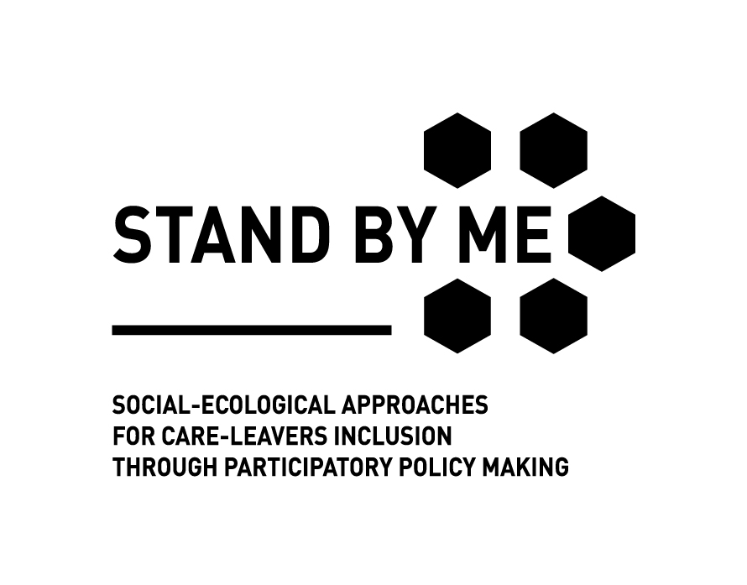



This project was funded by

the European Union’s Rights,

Equality and Citizenship

Programme (2014-2020)